EVC Draws Power from the Grid in Green Mode

Author: Daniel
Reviewer: Eason
FAQ/ EVC
Issue introduction
The customer does not want the EVC to draw power from the grid while in green mode.
Confirmation of basic information
[Photo]SN number of the EVC
Guidance for installer
Step1: Check the current level set in green mode. If it is set to 3A, change it to 6A.
Setting Path: Setting→Charger Setting→Work Mode Setting
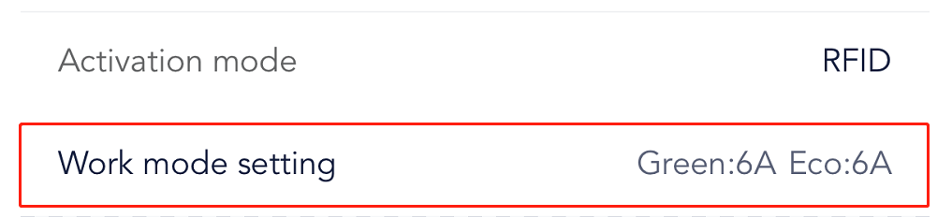
In green mode, when the current level is set to 3A, the EVC will start working when the PV surplus current reaches 3A.
If the PV surplus current is between 3A and 6A, the EVC will draw power from the grid to bring the current up to 6A.If the current level is set to 6A, the EVC will only start charging when the PV surplus current reaches 6A and the EVC will not draw power from the grid.
Step2: Check the Boost setting, when the boost setting is enabled, the EVC may draw power from the grid even in green mode, for boost setting has a higher priority than green mode.
Setting Path: Function Control→Boost Setting
Timed Boost | Smart Boost
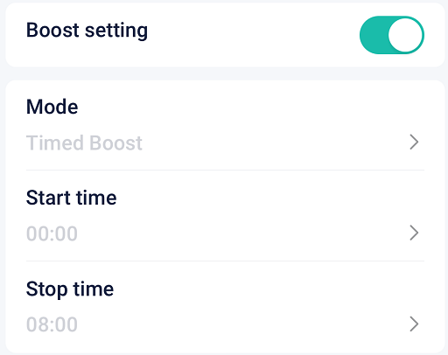 | 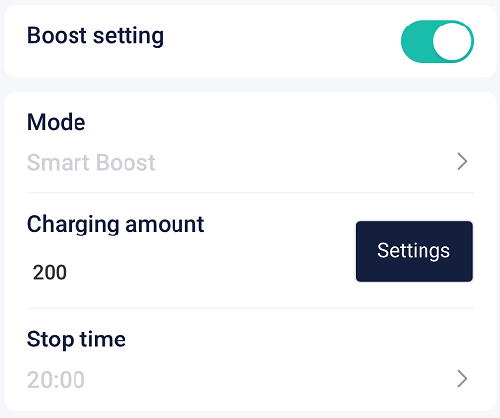
By enabling the “Timed Boost” feature, the user can set a time period. During this time period, The EVC will use all available power from both the PV and the grid to reach the maximum charging current (just like Fast mode). | By enabling the “Smart Boost” feature, the user can set the charging amount and stop time. To ensure that the charging amount is reached before the set stop time, the grid power may be used.
Step3: Check the reservation settings, for this setting has a higher priority than the green mode and may cause the EVC to draw power from the grid.
Setting Path: Function Control→Reservation Settings
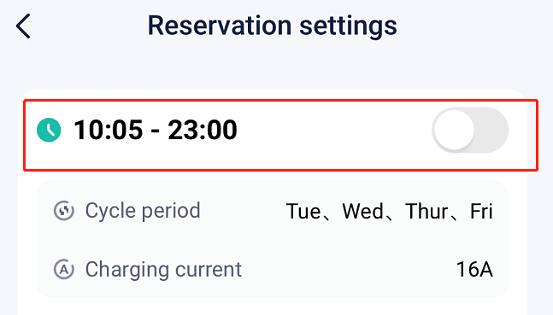
When the reservation settings are enabled, the EVC will charge at the set “Charging current” during the time period within each cycle. If PV surplus cannot meet the set current, the EVC will draw power from the grid.
Step4: Upgrade the EVC and the inverter to the latest firmware version.
Step5: EVC needs the correct information of grid connection point from the meter/CT to function properly in green mode. Therefore, you need to check if the CT/meter is installed correctly.
Situation1<EVC communicates with inverter>
Because the operation of the green mode depends on the direction and magnitude of the current in the grid connection point information, it is crucial to ensure that the inverter receives the correct grid connection point information.
Step1: Turn off all the loads and set the inverter to forced charge mode.
Setting Path: Mode Select➡️Manual➡️Forced Charge
Step2: Check if the power of each phase in “On-grid” is similar to the power in “Meter/CT” in the system status, a difference of less than 100W between the two is considered normal. The information needs to be queried locally through the inverter's screen
On-grid status on the inverter  Setting Path: System Status➡️ On-grid | Meter/CT power measured on the inverter  Setting Path: System Status➡️ Meter/CT
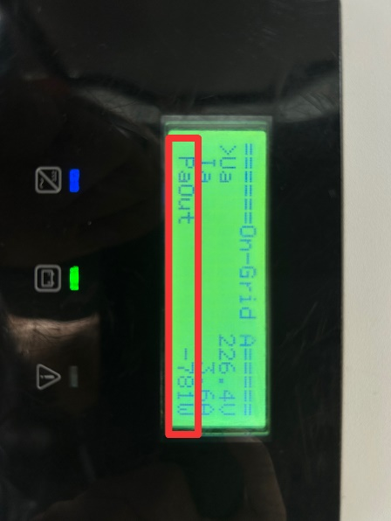 | 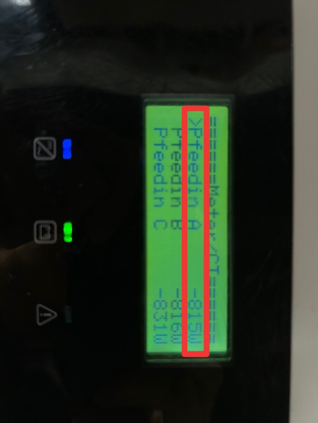
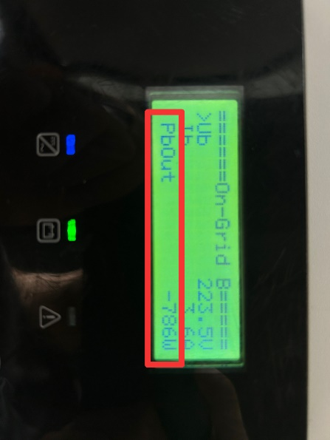 | 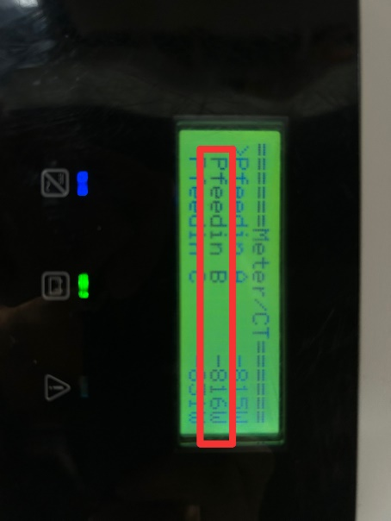
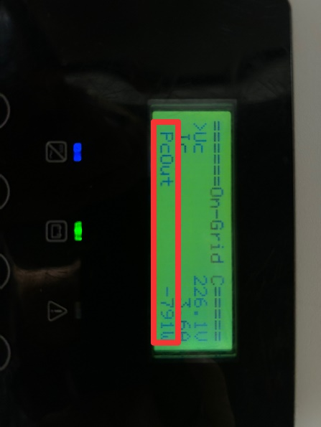 | 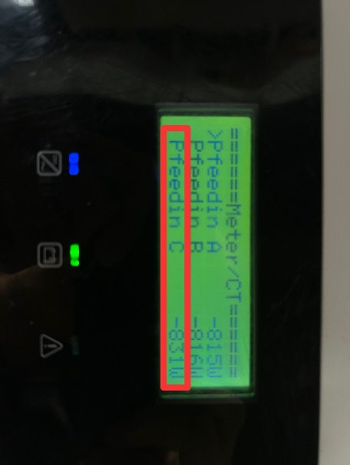
If the power displayed on on-grid status and on meter/CT status are similar in magnitude but one is positive and the other is negative, it indicates that the installation direction of the CT/meter is incorrect. Reinstall the CT/meter in the correct direction.
Situation2 <EVC communicates with CT/Meter>
When the EVC communicates with a meter/CT, the EVC directly obtains the data of the grid connection point from the meter/CT.
Step1: Ensure that the CT/meter is connected to the grid connection point.
Step2: When using a CT, confirm that the arrow on the CT is pointing toward the grid.
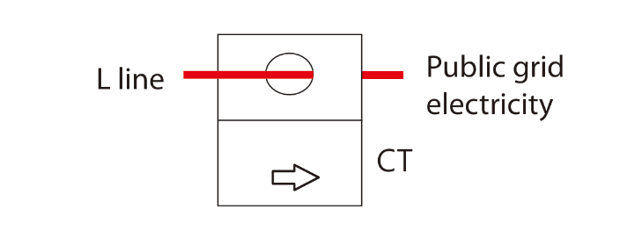
When using a meter, ensure the grid side of the meter is pointing toward the grid. (For fusion version, it can only use CT)
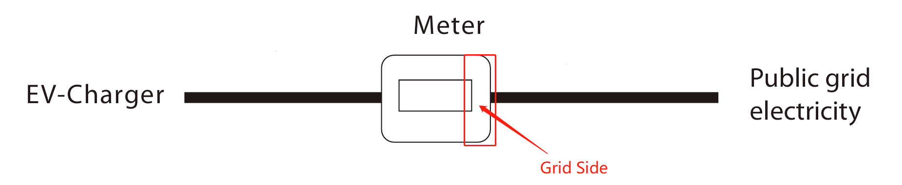
Information check list
If you have completed the above <Guidance for installer>, and the problem is still not solved, please collect the following troubleshooting information and send them to the R&D.
1.[Photo]EVC information including SN and registration numbers.
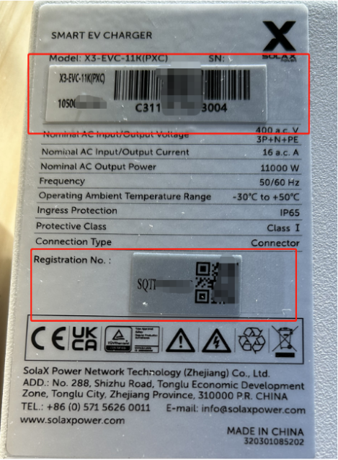
2.[Photo]Current level setting in green mode.

3.[Photo]Boost settings.
Timed Boost | Smart Boost
 | 
4.[Photo]Reservation setting.

5.[Photo] Meter/CT status and on-grid status on the inverter after turning off all the loads and setting the inverter to forced charge mode when EVC communicates with inverter.
On-grid status on the inverter | Meter/CT power measured on the inverter
 | 
 | 
 | 
6.[Photo]CT position and direction when EVC communicates with meter/CT.

7.[Photo]Meter position and direction when EVC communicates with meter/CT.


